# BON SECOURS ARTS AND SCIENCE COLLEGE FOR WOMEN.

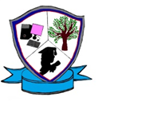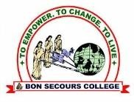 **(AffiliatedtoMotherTeresaUniversity,Kodaikanal)**

**Madurai main road,Begampur(PO),Dindigul–624002.**

**DEPARTMENT OF COMPUTER APPLICATIONS**

**STUDENTS DEVELOPMENT PROGRAMME**

REPORT ON SDP –“ MIND & MEDIA GAME “ on 28.06.2024

The Department of Computer Application conducted the Student Development Programme – “Mind & Media Game 2024 “,for the First Year Students in the academic year 2024-2025. A short intro about BCA department was given by Mrs.D.SarojPriyadharsini, Head/Assistant Professor of BCA.Then the students started the Events.The first game was “Word Scramble” and it was conducted by senior Students A.Ashika & their team. Totally 3 rounds were conducted and the winners were appreciated. Then the second game was “Start Music” and it was conducted by II & III BCA Students V.Rajeshwari & their team. Totally 4 rounds were conducted the winners were appreciated. We divided all the first year students into 3 batches and each batch contains more than 90 students. The department of B.Com (CA) and BBA students were under the first batch from 9.30 to 10.30a.m.The department of BCA,B.Sc.,CS,B.A.English,B.Sc.,Maths students were under the second batch from 10.30 to 11.30a.m. The department of B.Sc., Chemistry, B.Com, B.A.Tamil students were under the third batch from 11.45 to 1.05p.m. The students were very interestedly participated in the SDP and nearly 300 students were attended and benefited. We got the feedback from each batch students.

**PHOTOS**

